WHLF- Backyard Kiwi Report for 2025-2026


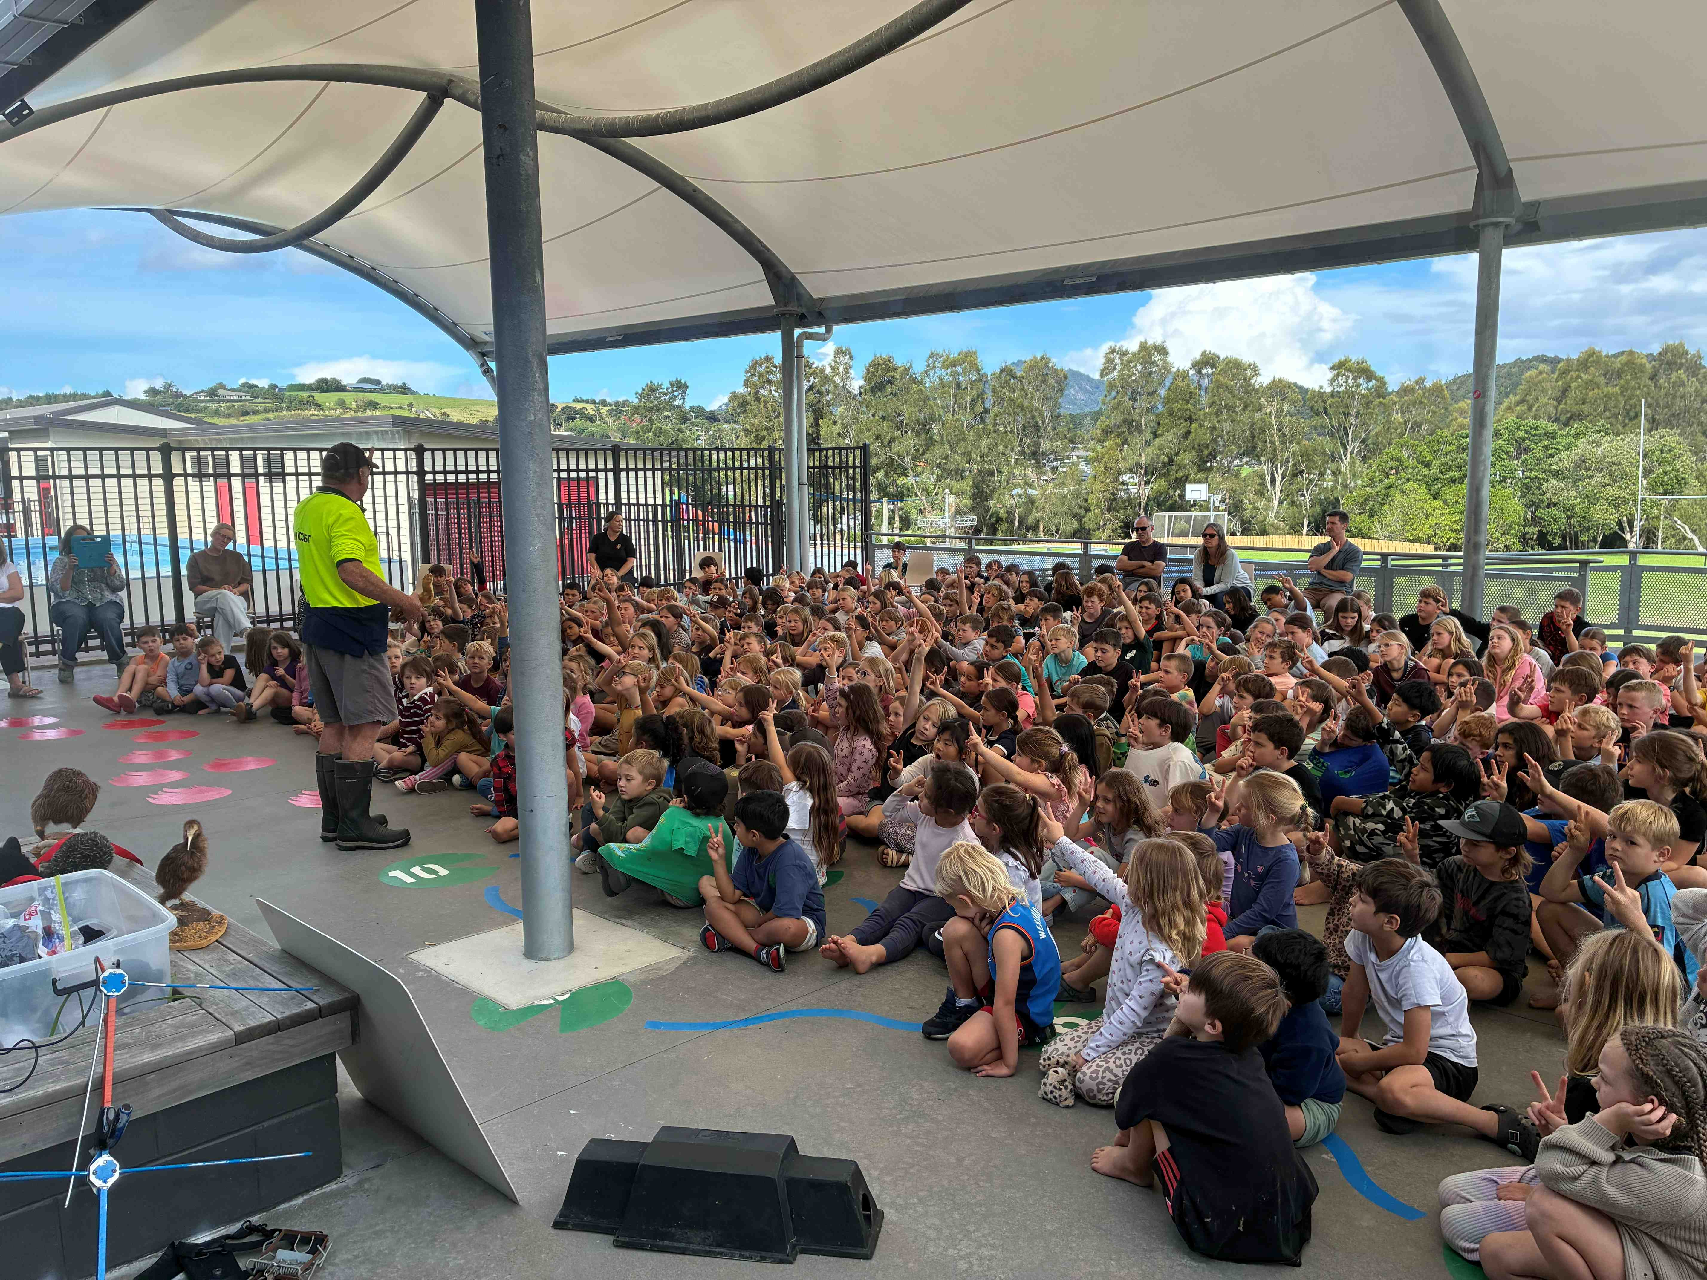

Backyard Kiwi Programme

Twenty-five years of successful kiwi recovery work has seen the Whangarei Heads kiwi population increase from approximate 80 kiwi in 2001 to an estimated 1,330 in 2025. This kiwi population is also expanding northwards into the Kiwi Link area. Backyard Kiwi is one of the most successful kiwi recovery projects in New Zealand.

This report covers the work done by BYK in the period July 2025 to June 2026:

- Predator Control: Maintaining a comprehensive and effective predator trapping network targeting mustelids (ferrets, stoats and weasels) and feral cats over an 8000ha plus area. Complementing the trapping network with periodic ground based secondary poison pulses in selected areas to remove trap shy stoats that build up in any trapping system.

- Outcome Monitoring: Monitoring of the kiwi population through annual kiwi counts from 19 listening stations and by radio telemetry monitoring of a sample of kiwi fitted with radio transmitters.

- Community Engagement and Good Dog Control: Community engagement is critical. Public kiwi releases, the Backyard Kiwi website, facebook page, signage and radio monitoring of kiwi are all encouraging the community to value and look after the kiwi in their backyards. As uncontrolled dogs are the major threat to adult kiwi this public engagement is crucial to the long-term sustainability of the Whangarei Heads kiwi population.

A significant added benefit of kiwi recovery work is that it is also helping to increase many other biodiversity values in the area – including bittern and kukupa.

There has also been a positive strengthening of the Whangarei Heads community through this community driven kiwi recovery work.

Kiwi Predator Control
In unmanaged areas of New Zealand 95% of kiwi chicks are predated in their first 6 months of life, primarily by stoats. Control of Stoat and other predators at the Whangarei Heads has dramatically improved the survival rate of the kiwi chicks. Since 2002 we have been operating a kiwi predator trapping network over an approximate 8000ha area. Catch data is summarized below.

Captures by Backyard Kiwi predator trap network
 | Ferret | Stoat | Weasel | Cat | Hedgehog | Rat | Possum
2002/2003 | 1 | 55 | 46 | 18 | 65 | 391 | NA
2003/2004 | 4 | 22 | 21 | 22 | 52 | 319 | 24
2004/2005 | 1 | 30 | 17 | 38 | 95 | 403 | 285
2005/2006 | 0 | 26 | 13 | 29 | 82 | 357 | 191+
2006/2007 | 0 | 26 | 8 | 17 | 68 | 304 | 147
2007/2008 | 0 | 19 | 22 | 18 | 84 | 346 | 75+
2008/2009 | 0 | 21 | 25 | 12 | 112 | 351 | 144+
2009/2010 | 0 | 17 | 20 | 20 | 87 | 321 | 139+
2010/2011 | 1 | 24 | 27 | 15 | 86 | 338 | 109+
2011/2012 | 0 | 25 | 27 | 20 | 56 | 390 | 98+
2012/2013 | 0 | 42 | 20 | 19 | 49 | 421 | 148+
2013/2014 | 0 | 19 | 33 | 24 | 140 | 475 | 128+
2014/2015 | 0 | 18 | 29 | 22 | 149 | 654 | 131
2015/2016 | 0 | 16 | 41 | 30 | 126 | 765 | 126
2016/2017 | 1 | 17 | 42 | 49 | 129 | 674 | 72
2017/2018 | 0 | 22 | 41 | 27 | 129 | 686 | 90
2018/2019 | 0 | 21 | 27 | 35 | 150 | 765 | 143
2019/2020 | 0 | 28 | 30 | 12 | 126 | 800 | 63
2020/2021 | 0 | 14 | 18 | 22 | 135 | 733 | 68
2021/2022 | 0 | 21 | 27 | 15 | 99 | 958 | 64
2022/2023 | 0 | 33 | 38 | 18 | 44 | 971 | 64
2023/2024 | 0 | 21 | 49 | 13 | 40 | 1,104 | 87
2024/2025 | 0 | 15 | 49 | 11 | 56 | 1,148 | 64
2025/2026 | 0 | 16 | 92 | 9 | 95 | 1,022 | 58
Total | 8 | 569 | 772 | 514 | 2,245 | 14,697 | 2,770+

Points of note from this year’s catch tallies:

- 16 Stoats caught is the third lowest tally, the annual average is 24 stoats. This is probably a result of the effectiveness of the targeted, bait station based, Kiwi Saver/1080 pulses undertaken this season (see details below). The Whangarei Predator Free (WPF) trail camera network reinforces this with low stoat numbers detected in the Whangarei Heads area.

- 92 Weasels is a record high catch by a significant margin, and this is also probably a reflection of the low stoat numbers (as stoats predate on weasels). The long term weasel catch average is 28 per year. Back in 2002 the Stoat:Weasel catch ratio was less than 1:1 (55:46), it is now over 1:5 (16:92). Weasels also have a much smaller home range meaning a higher density of traps/baitstations is needed for their control. Weasels are not a threat to kiwi.

- 9 Cats is a record low but the trapping effort has reduced. Long term average of 23 cats. Even so, it is likely that there is better cat owner control and anecdotally there is less dumping of cats in the area, but it is very difficult to read much into this.

- 1,022 Rat total (includes 39 Norway rats) is another high rat catch, following the upward trend over the past 24 years. Initial catch was 391 in 2002, with a long term average of 569.

- 95 Hedgehogs is a significant increase after the recent years of low catches, but still well off the peak of 149 in 2014. In theory they are very hard to control by trapping. Environmental conditions such as floods and droughts may be having an impact on hedgehog populations. Maybe even competition from kiwi? This summer/autumn there were good feeding conditions for both hedgehogs and kiwi.

- 58 Possums. These are a bycatch as possums are not specifically targeted by the predator trap network. There are still a scattering of possums at the Heads.

It is important to note that it does not matter how good a predator trapping network is - over time it becomes less effective due to trap/lure shy stoats. To clear these trap/lure shy stoats out of the area we use a controlled pulse of toxin in bait stations that kills the stoats by secondary poisoning via rats. ‘Kiwi Saver’ (1080) is the best toxin for this purpose. It is a crucial component of stoat control in any landscape area and is particularly effective on a peninsula like the Heads. Kiwi Saver/1080 is able to be used due to the trust BYK has built up in the community.

This year there were Kiwi Saver pulses at Manaia (by Manaia LC), Kauri Mt and coastal strip (by WPF) and on private blocks. Brodifacoum (also a secondary poison) pulses on private land were also carried out by WPF as they targeted possums.

The ongoing combination of an extensive trapping network and a controlled secondary toxin pulse continues to ensure good kiwi chick survival in our area. This is supported by the evidence of increasing kiwi count numbers and the (unfortunate) number of chicks that have survived to be in excess of 1000g in weight (stoats can kill young kiwi up to 1000g in weight) turning up as road kill.

Ferrets can kill adult kiwi. No ferrets were caught in our trapping area this year but several were caught in the wider Whangarei area so we continue to use traps capable of catching ferrets as they would have a devastating impact on the kiwi population.

The major funder of the Backyard Kiwi trapping program is the “NRC pest management rate” for the Whangarei Heads High Value Area which funds pest control (kiwi predators and also weed control) in that area specifically. Thanks to Rolf Fuchs of the NRC for helping us manage this funding. This is a great use of local funding by locals for a local project.

Outcome Monitoring – Is it working?

Is it working?

Our local community contributes significantly to our annual kiwi count with a team of 30 listeners monitoring a network of 19 sites during the kiwi breeding season. The 2026 count is currently underway and will be processed and reported on shortly. The 2025 data is reported on here.

Average kiwi call counts have risen from 2.9 calls per station per hour in 2002 to 12.3 calls in 2025. We also use directional call sheet analysis that provides an estimate of adult kiwi numbers. In 2025 that estimate was 1,330 kiwi - up from only 80 in 2001. This is an annual growth of over 10% compared with the national average of a decline of 2%. So it is most definitely working!

Another benefit of the increasing population is the significant numbers of kiwi that are now moving northwards out of the traditional kiwi area of the Whangarei Heads into the wider Parua Bay area and beyond into the “Kiwi Link” area. Kiwi numbers continue to grow in this area.

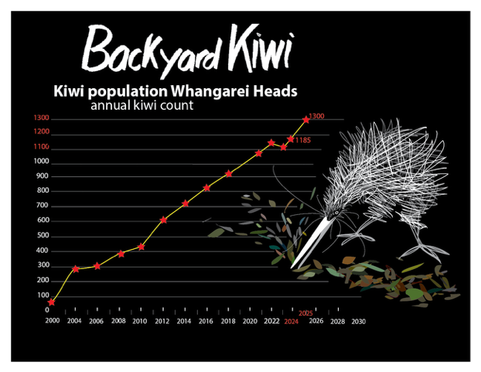

Kiwi Deaths

There have been 12 known adult kiwi deaths at the Whangarei Heads in the past 12 months. 7 from road kill, 2 from unknown causes, 1 from cat nematodes, 1 probable dog kill and 1 definite dog kill. There will be other unknown or unreported deaths. All these deaths were reported by locals. Only one of the dead kiwi had an ID chip so all the others were wild hatched and grown kiwi. This is another strong indicator of the effectiveness of our stoat and dog control leading to strong recruitment and a growing population.

The ongoing reduction in dog kills of kiwi around the residential villages is a credit to the Whangarei Heads community who, in the vast majority of cases, are showing great control of their pets. Dogs free to roam on lifestyle blocks are still a risk. The significant number of new people moving to the area are bringing more dogs and it is an ongoing challenge to engage with dog owners new to the district. The ethic of dog control is strong in our community and appears to be influencing most newcomers at this stage. We work hard with kiwi releases and other engagement opportunities to tell the “Take the Lead” story to ensure our dogs don’t kill our kiwi.
Note that kiwi aversion training for pet dogs does is not supported by BYK – it does not work (as shown by scientific studies and our practical experience) and has led to multiple kiwi deaths at the Heads. Kiwi aversion training for pet dogs should be avoided.

Kiwi Radio Monitoring Program at the Whangarei Heads/Parua Bay

An important part of the community engagement work at the Whangarei Heads/Parua Bay is the radio monitoring of a sample of kiwi and updating of landowners and other locals of where and what those birds are doing. The BYK project team keeps the community updated through personal contact, emails, newsletters, our website and facebook. As more radio monitored kiwi move into and through the Kiwi Link area to the west of Parua Bay this monitoring is become more important in that area and will hopefully lead to improved dog control there as locals become more aware.

Operation Nest Chick (ONC)- Engagement program – funded by Kiwi Coast

This is a joint program involving Backyard Kiwi, FOMLI and the Kiwi Coast with the crucial support of Ngati Hine, DoC and landowners. The program provides for local kiwi releases.

This season we monitored 10 breeding males in the DoC managed Purua block and surrounding farm land. The first half of the breeding season went well but there were no second clutch chicks this year. 8 chicks were successfully transferred to Limestone/Matakohe (15 chicks is our long term average).

7 sub-adult and adult kiwi have been recaptured on Limestone and transferred for release. They were the stars of our releases engaging people with their kiwi leading to better dog control and ongoing support for trapping and controlled toxin pulsing. This year we visited both the Whangarei Heads and Parua Bay Schools so 430 local kids (and their teachers) got to meet their kiwi up close and hear about the importance of good dog control.

We obtained a variation to our release permit from DoC that enabled 3 kiwi to be released and monitored by Piroa Landcare (south of Waipu). This was a highly successful event. Their release and monitoring is adding to the successful community driven kiwi recovery in the Piroa area. Prior to releases in 2013 by DoC kiwi were extinct there.

Thanks to Tamra Gibson, AJ Savage, Hugh Robertson and Julia Brady of DoC, Rolf Fuchs of NRC, Bevan Morgan of FOMLI, Ngaire Sullivan of Kiwi Coast and our BYK committee for their support with this important work.

Backyard Kiwi Engagement – “Telling the Story”

With uncontrolled dogs and road kill the biggest threats to the Whangarei Heads kiwi population, our “Backyard Kiwi” community engagement remains crucial. In additional to personal contact that engagement includes:

Signage

Main sign at turn off, interpretation signs at the Parua Bay garage and “the Deck” and 9 other road signs. The “Kiwi crossing” signs are at the road kill hotspot. The “Take the Lead” sign on the Parua Bay hill is aimed directly at dog owners. We also have a “notice board” sign opposite the Parua Bay Cemetery to update locals. The feedback from this signage is always very positive. The new owners of the Parua Bay Garage are keen on replacement of that sign.

“Telling the Story”:

- Website –over 1000 hits per month – monthly reports and kiwi locations maps with news is regularly updated. This website has recently undergone a major revamp thanks to Heather Hunt and Max Tyson and is due to go live soon.
- The BYK YouTube video channel features a series of professionally crafted videos on the BYK story and our work.
- BYK facebook, run by Helen Moodie, is used to update folks and alert new information on the website. It has over 3000 followers. Several posts reached over 12,000 people this year.
- Regular contribution to WHCA Community Newsletters.
- Visits to the both local schools.
- Multiple newspaper articles with the Advocate quick to pick up on BYK kiwi stories.
- BYK artwork covers Todd’s ute thanks to support from Heather Hunt and funding from our proud supporters.
- Our “I saw a kiwi” and “I heard a kiwi” bumper stickers feature on many cars in the district.
- Our Backyard Kiwi and “Take the Lead” pamphlets to help inform visitors about kiwi at the Whangarei Heads are been picked up regularly from the local cafes and shops.
- Yet another rerun of the “Rural Delivery” TV show featured the BYK/Kiwi Coast story and once again got a good positive reaction locally and wider. This TV story just keeps on giving positive profile to BYK.
- More FM’s Toast and Tania (a Parua Bay local) did an interview with Todd, who emphasized the importance of good dog control.

Our kiwi releases and radio monitoring of released kiwi continues to be a cornerstone of engaging locals with their kiwi. As the kiwi spread inland from our original recovery area more and more people are experiencing the reward of kiwi in their backyard.
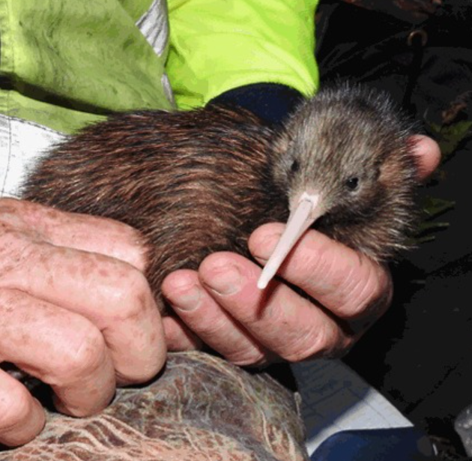

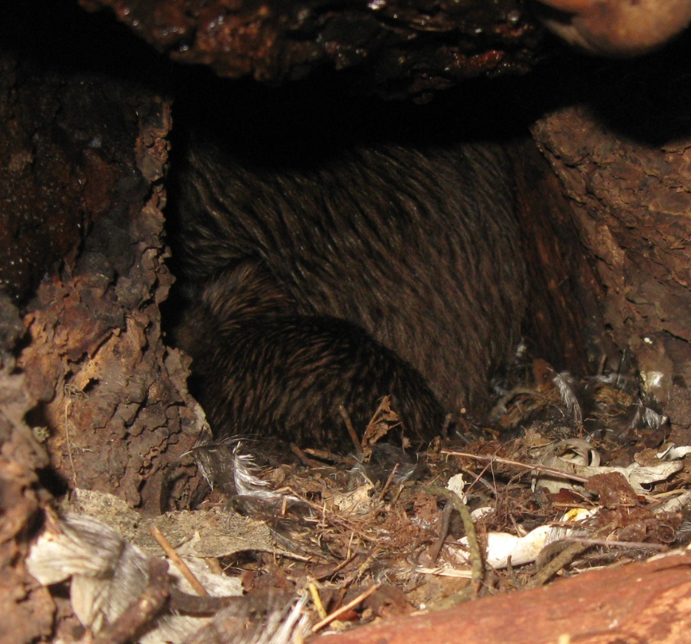

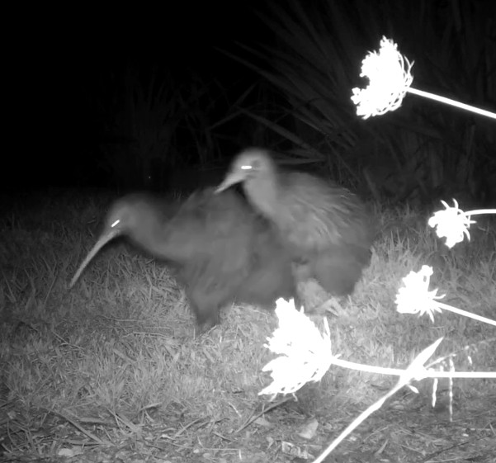

BYK disagreement over territory caught on camera

Proud Supporters

The ongoing financial contributions from Backyard Kiwi Proud Supporters (Local businesses and individuals) are invaluable to sustaining kiwi recovery efforts to “Tell the Story”. However it has been another tough year with a significant reduction in financial support from locals – at least partly because of the misconception that we are now well funded through Whangarei Predator Free (which is focusing on possum eradication at this stage).

These supporters include: Boon Yap – Feng Shui Workshops, Allen Howell, Parua Bay School, Onerahi & Whangarei Heads Lions Club, Lionel Sands, Manaia Excavators, Fay Evans, Beth Moodie, Heather Hunt Illustration, Sue and Wayne Morris, John Wright and Integrated Electrical and Solar

THANKS!! to you all.

Budget

The 2025-2026 work program for predator control, kiwi monitoring and project management had a NRC Whangarei Heads High Value Area budget of $91,000 (this does not include the ONC program or telling the BYK story). The program is running to budget. This is excellent value for money with trapping costs at $5/ha (the norm is $10/ha and often far more) and monitoring costs $2/ha. Community support for this expenditure remains strong - a great example of local funding by locals for a local project.

Summary

Our kiwi recovery work continues to be very successful with the kiwi population at Whangarei Heads growing and expanding northwards. Continued stoat control is still crucial for kiwi chick survival and ongoing dog control through telling the kiwi story is essential for adult survival. Things are going well but as always kiwi recovery still needs our continued efforts.


Todd Hamilton
Backyard Kiwi Project Manager
Whangarei Heads Landcare Forum
M 021 1145 385
E todd.hamilton64@gmail.com
W www.backyardkiwi.org.nz

